Claude Certification — Building with the Claude API
Section 3 — Prompt Evaluation
Contents
- Lesson 1 — Prompt Evaluation
- Lesson 2 — A Typical Eval Workflow

Lesson 1 — Prompt Evaluation

Core idea
Writing a good prompt is just the beginning. To build reliable AI applications you need two complementary concepts: prompt engineering gives you techniques for writing better prompts, while prompt evaluation helps you measure how well those prompts actually work. Evaluation is automated testing for prompts.

Key points
- Prompt engineering = how you write the prompt. Prompt evaluation = how you measure it.
- Evaluation is automated testing — test against expected answers, compare prompt versions, and review outputs for errors.
- After drafting a prompt you face three options: test it once, test it a few times, or run it through an evaluation pipeline.
- Options 1 and 2 are common traps — we underestimate how many edge cases real users hit.
- Option 3 (the evaluation-first approach) costs more work but gives objective metrics and real confidence.
- The goal: catch problems during development, not after users encounter them.

Prompt engineering vs prompt evaluation
Prompt engineering is your toolkit for crafting effective prompts. It includes techniques like multishot prompting, structuring with XML tags, and many other best practices. These techniques help Claude understand exactly what you're asking for and how you want it to respond.
Prompt evaluation takes a different approach. Instead of focusing on how to write prompts, it's about measuring their effectiveness through automated testing. With evaluation you can test against expected answers, compare different versions of the same prompt, and review outputs for errors. The two are complementary, not alternatives: engineering produces the candidate, evaluation tells you whether the candidate is actually good.
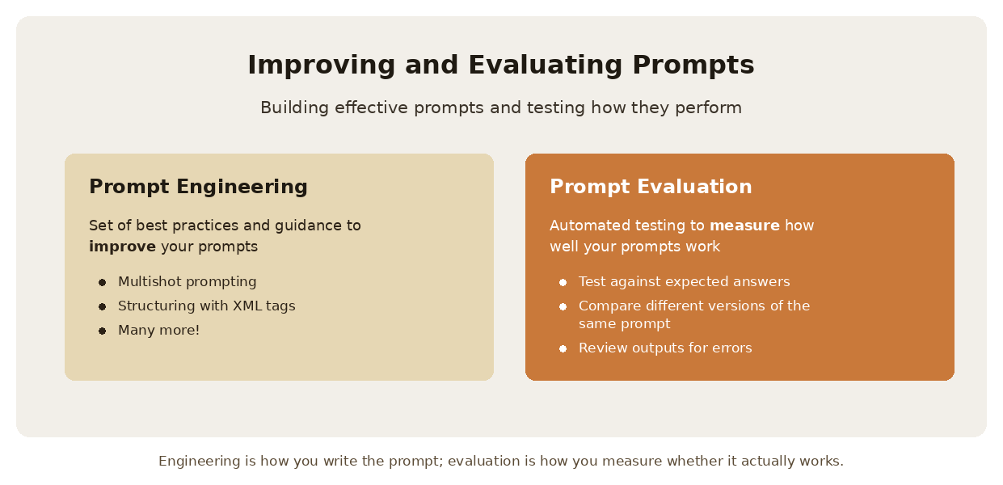
Two sides of the same job: building effective prompts, and testing how they perform.
Prompt Engineering | Prompt Evaluation
Set of best practices and guidance to improve your prompts | Automated testing to measure how well your prompts work
Multishot prompting | Test against expected answers
Structuring with XML tags | Compare different versions of the same prompt
Many more best practices | Review outputs for errors

Three paths after writing a prompt
Once you've drafted a prompt, you typically face three options for what to do next. Option 1: test the prompt once and decide it's good enough — this carries a significant risk of breaking in production when users provide unexpected inputs. Option 2: test the prompt a few times and tweak it to handle a corner case or two — better than option 1, but users will often provide very unexpected outputs that you haven't considered. Option 3: run the prompt through an evaluation pipeline to score it, then iterate on the prompt based on objective metrics — this requires more work and cost, but gives you much more confidence in your prompt's reliability.
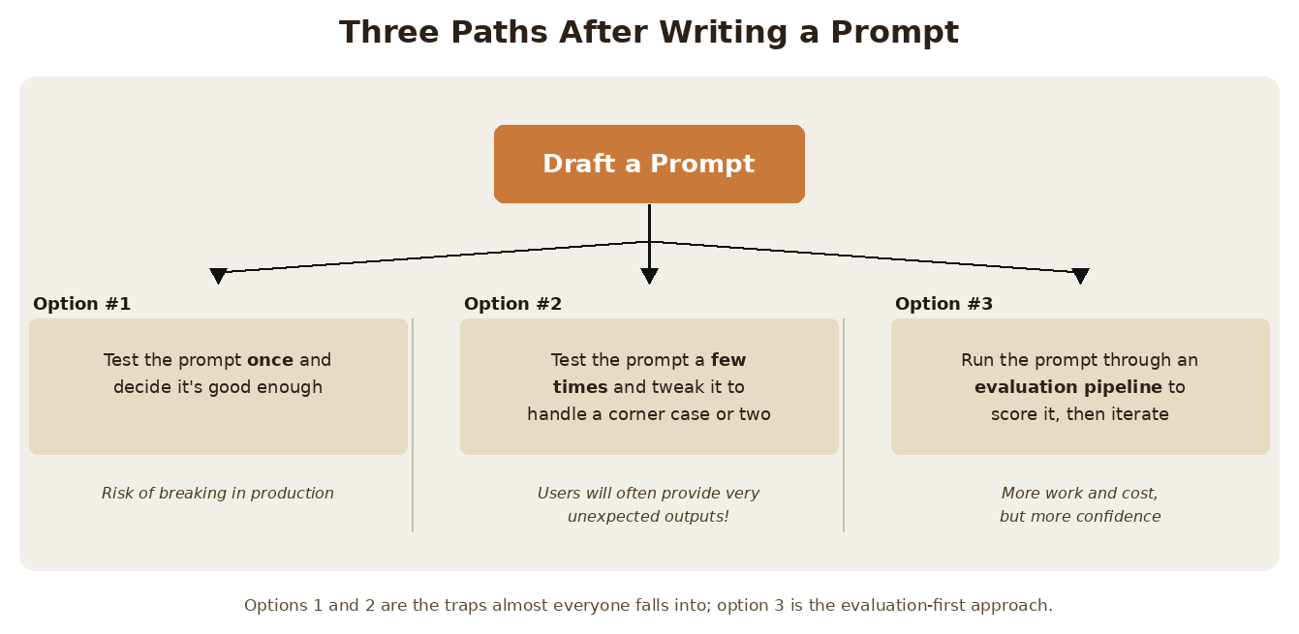
The three options, with the trade-off written under each one.
Option | What it is
Option 1 | Test the prompt once and decide it's good enough — risk of breaking in production
Option 2 | Test a few times and tweak for a corner case or two — users still provide very unexpected outputs
Option 3 | Run the prompt through an evaluation pipeline to score it, then iterate — more work and cost, but more confidence

Why most engineers fall into testing traps
Options 1 and 2 are common traps that all engineers fall into — the course author included. It's natural to write a prompt for a serious application and not test it thoroughly enough. We tend to underestimate how many edge cases real users will encounter.
The reality is that when you deploy a prompt to production, users will interact with it in ways you never anticipated. What seemed like a solid prompt during your limited testing can quickly break down when faced with the full variety of real-world inputs. The problem isn't that the prompt was bad — it's that a handful of manual tests can't represent the input space your users actually produce.

The evaluation-first approach
Option 3 represents a more systematic approach to prompt development. By running your prompt through an evaluation pipeline, you get objective metrics about its performance across a broader range of test cases. This data-driven approach lets you identify weaknesses before they become production issues, compare different prompt versions objectively, iterate with confidence based on measurable improvements, and build more reliable AI applications.
- Identify weaknesses before they become production issues.
- Compare different prompt versions objectively.
- Iterate with confidence based on measurable improvements.
- Build more reliable AI applications.
While this approach requires more upfront investment in time and testing infrastructure, it pays dividends in the reliability and robustness of your final application. The goal is to catch problems during development rather than after your users encounter them.

Practice Questions — Lesson 1
Choose the single best answer for each question (A–E).
1. What is the difference between prompt engineering and prompt evaluation?
A) Engineering is for production, evaluation is only for development
B) Engineering is a set of techniques for writing better prompts; evaluation measures how well those prompts work
C) Engineering applies to system prompts, evaluation applies to user messages
D) They are two names for the same practice
E) Engineering is automated, evaluation is manual
2. Which of the following is an activity of prompt evaluation rather than prompt engineering?
A) Multishot prompting
B) Structuring the prompt with XML tags
C) Testing outputs against expected answers
D) Rewriting the prompt to be clearer
E) Choosing a role for the system prompt
3. What is the main risk of Option 1 — testing the prompt once and deciding it's good enough?
A) It uses too many tokens during development
B) It risks breaking in production when users provide unexpected inputs
C) It makes the prompt too long for the context window
D) It forces you to use a more expensive model
E) It prevents you from using a system prompt later
4. According to the lesson, why is Option 2 — testing a few times and fixing a corner case — still not enough?
A) Because Claude's responses change every time regardless of the prompt
B) Because users will often provide very unexpected inputs you haven't considered
C) Because corner cases can only be fixed by lowering the temperature
D) Because manual testing is not allowed in production applications
E) Because a prompt can only be edited a limited number of times
5. What is the stated goal of the evaluation-first approach?
A) To reduce the cost of every API request
B) To remove the need for prompt engineering entirely
C) To catch problems during development rather than after users encounter them
D) To make Claude's outputs completely deterministic
E) To replace human review with a single automated test

Lesson 2 — A Typical Eval Workflow

Core idea
A typical prompt evaluation workflow follows five key steps that help you systematically improve your prompts through objective measurement: draft a prompt, create an eval dataset, feed it through Claude, feed the results through a grader, then change the prompt and repeat. There are many ways to assemble these workflows and various open source and paid tools available, but understanding the core process lets you start small and scale up as needed.

Key points
- The five steps: Draft a Prompt → Create an Eval Dataset → Feed Through Claude → Feed Through a Grader → Change Prompt and Repeat.
- The prompt is a template — the dataset questions get interpolated into it ({question}).
- The eval dataset can be assembled by hand or generated by Claude; real evaluations may have tens, hundreds or thousands of records.
- The grader looks at both the question and the answer, and scores typically from 1 to 10.
- The average score across all questions is your objective measurement — the baseline you try to beat.
- Step 5 makes it a loop: change the prompt, rerun everything, and compare the new average against the old one.

The workflow at a glance
There are many different ways to assemble a workflow and many different open source and paid options available. In this module the course assembles its own workflow from scratch, which is the best way to understand what the paid tools are actually doing for you.
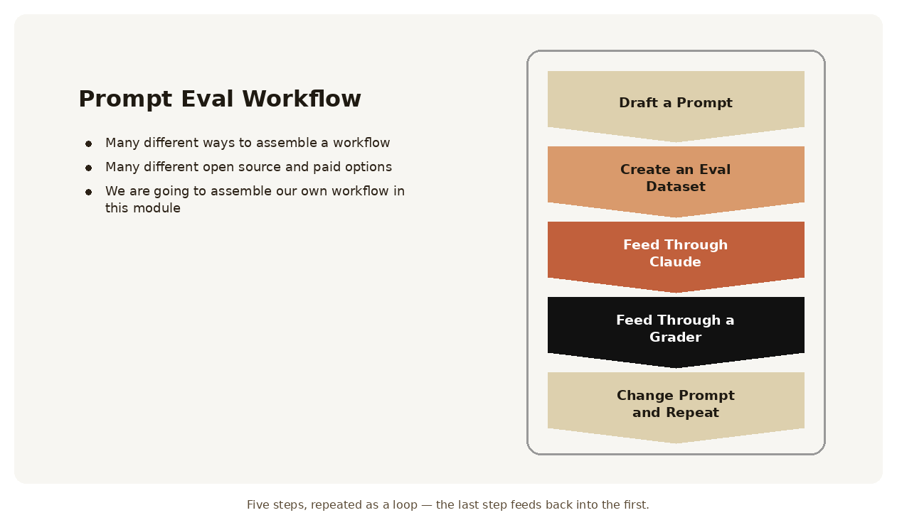
The five steps of a prompt evaluation workflow, in order.
Step | What happens
1. Draft a Prompt | Write the initial prompt template you want to improve
2. Create an Eval Dataset | Collect sample inputs representing what the prompt will handle in production
3. Feed Through Claude | Merge each dataset record into the template and send it to Claude
4. Feed Through a Grader | Score each question/answer pair objectively, then average the scores
5. Change Prompt and Repeat | Modify the prompt and rerun the whole process to see if the score improves

Step 1 — Draft a Prompt
Start by writing an initial prompt that you want to improve. Notice that it's a template: the {question} placeholder is where each dataset record will be interpolated. For this example the course uses a deliberately simple prompt:
prompt = f"""
Please answer the user's question:

{question}
"""
Will this be an effective prompt? We won't know until we evaluate it with some objective methodology. This basic prompt serves as our baseline for testing and improvement.

Step 2 — Create an Eval Dataset
Your evaluation dataset contains sample inputs that represent the types of questions or requests your prompt will handle in production. The dataset should include questions that will be interpolated into your prompt template. For this example the dataset includes three questions: "What's 2+2?", "How do I make oatmeal?", and "How far away is the Moon?". In real-world evaluations you might have tens, hundreds, or even thousands of records. You can assemble these datasets by hand or use Claude to generate them for you.
Eval dataset — key facts | Detail
What it contains | Questions that will be merged with your prompt template
How it is built | By hand, or generated by Claude
Realistic size | Tens, hundreds, or even thousands of records
What it must represent | The types of requests your prompt will actually handle in production

Step 3 — Feed Through Claude
Take each question from your dataset and merge it with your prompt template to create complete prompts. Then send each one to Claude to get responses. For example, the first question becomes:
Please answer the user's question:
What's 2+2?
Claude might respond with "2 + 2 = 4" for the math question, provide oatmeal cooking instructions for the second question, and give the distance to the Moon for the third. One dataset record produces one request and one response.
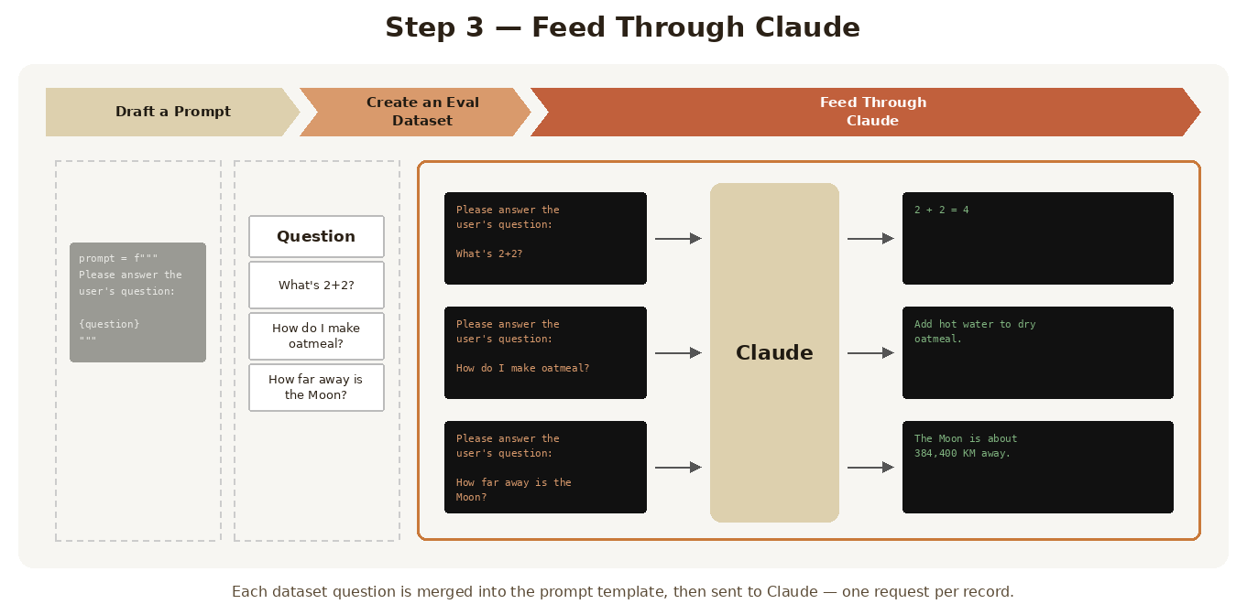
Each merged prompt goes to Claude individually, and each returns its own response.

Step 4 — Feed Through a Grader
The grader evaluates the quality of Claude's responses by examining both the original question and Claude's answer. This step provides objective scoring, typically on a scale from 1 to 10, where 10 represents a perfect answer and lower scores indicate room for improvement.
In the example, the grader might assign 10 to the math question (perfect answer), 4 to the oatmeal question (needs improvement), and 9 to the Moon question (very good answer). The average score across all questions gives you an objective measurement:
(10 + 4 + 9) ÷ 3 = 7.66
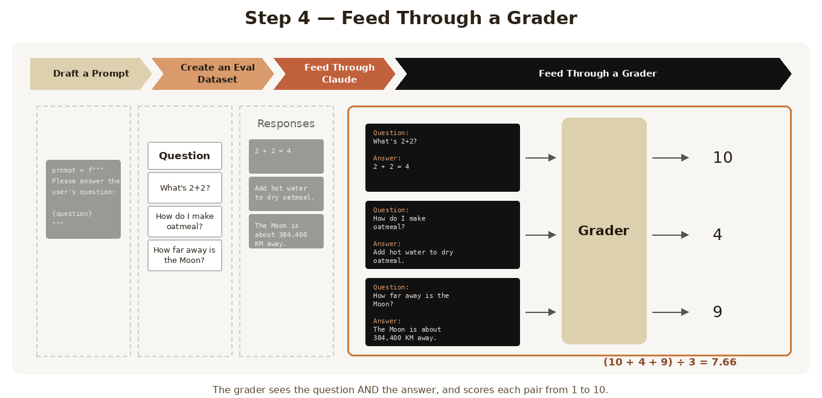
The grader receives the question/answer pair and returns a score; the scores are averaged into one number.
Question | Score
What's 2+2? | 10 — perfect answer
How do I make oatmeal? | 4 — needs improvement
How far away is the Moon? | 9 — very good answer
Average | 7.66 — the baseline score

Step 5 — Change Prompt and Repeat
Now that you have a baseline score, you can modify your prompt and run the entire process again to see if your changes improve performance. For example, you might add more guidance to your prompt:
prompt = f"""
Please answer the user's question:

{question}

Answer the question with ample detail
"""
After running this improved prompt through the same evaluation process, you might get a higher average score of 8.7, indicating that the additional instruction helped Claude provide better responses. Nothing about the dataset or the grader changed — only the prompt — so the difference in score is attributable to the prompt itself.

Prompt scoring
The key benefit of this workflow is getting objective measurements of prompt performance. You can compare different prompt versions numerically, use the version with the best score, and continue iterating to find even better approaches. This systematic approach removes guesswork from prompt engineering and gives you confidence that your changes are actually improvements rather than just different variations.
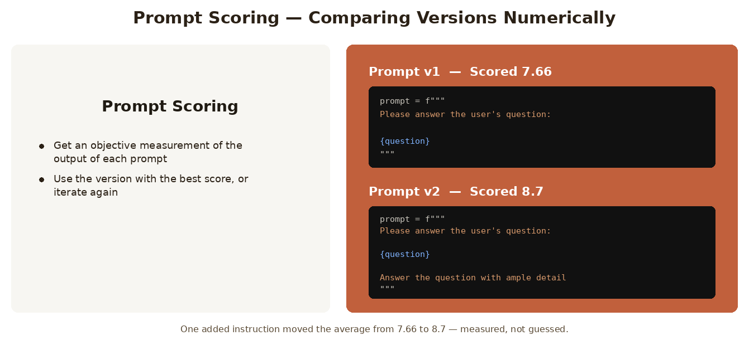
Two versions of the same prompt, each with a number attached — v2 wins, and you can prove it.

Practice Questions — Lesson 2
Choose the single best answer for each question (A–E).
1. What is the correct order of the five steps in a typical eval workflow?
A) Create an eval dataset → Draft a prompt → Feed through a grader → Feed through Claude → Repeat
B) Draft a prompt → Create an eval dataset → Feed through Claude → Feed through a grader → Change prompt and repeat
C) Draft a prompt → Feed through a grader → Feed through Claude → Create an eval dataset → Repeat
D) Feed through Claude → Draft a prompt → Create an eval dataset → Feed through a grader → Repeat
E) Create an eval dataset → Feed through Claude → Feed through a grader → Draft a prompt → Repeat
2. What does the eval dataset contain?
A) The scores assigned by the grader
B) Sample input questions that will be interpolated into the prompt template
C) Several finished versions of the prompt to choose from
D) Claude's responses from a previous evaluation run
E) The system prompts used by the grader
3. According to the lesson, how can an eval dataset be assembled?
A) Only by hand, since generated questions are not valid test cases
B) By hand, or generated by Claude
C) Only by exporting real production logs
D) Automatically by the grader after the first run
E) It is provided by the Anthropic API on request
4. What information does the grader examine when scoring?
A) Only Claude's answer
B) Only the original question
C) Both the original question and Claude's answer
D) The prompt template and the temperature setting
E) The token usage reported in the response
5. In the example, the scores were 10, 4 and 9. What was the resulting objective measurement?
A) 10 — the highest score obtained
B) 4 — the lowest score obtained
C) 23 — the sum of all scores
D) 7.66 — the average of the scores
E) 8.7 — the score of the improved prompt

